

**SHEARWATER HEALTH INVENTORY MANAGEMENT SYSTEM (SHIMS)**

In partial fulfillment of the requirements for the

Diploma in Information Technology

Prepared and Submitted By:

Vic Arthur G. Pintado

August 2018

**Project Title**

*Shearwater Health Inventory Management System (SHIMS)*

**Table of Contents**

Project Members ..……………………………………………………………………………………………………………… 3

Executive Summary ..………………………………………………………………………………………………………….. 3

I. Introduction …………………………………………………………………………..……………………………………….. 4

1.1 Project Context …………………………………………………………………...……………………………… 4

1.2 Purpose and Description ……………..………………………………………………………………………… 4

1.3 Objectives ………………………………………………………………………………………………………… 5

1.4 Scope and Limitations ………………………………………………………………………………………….. 5

II. Review of Related Literature / Systems ………………………………………………..…………………………………. 6

III. Technical Background ……………………………………………………………………………………………………... 8

IV. Methodology, Results, and Discussions …………………………………………………………………………………. 9

4.1 Events Table ………………………………………………………………………………………………..…… 9

4.2 Context Diagram ………………………………………………………………………………………………… 10

4.3 Level 1 Diagram ………………………………………………………………………………………………… 11

4.4 Functional Decomposition Program …………………………………………………………………………… 11

4.5 Use Case Diagram ……………………………………………………………………………………………… 12

4.6 Full Use Case Description ……………………………………………………………………………………… 13

4.7 Entity Relationship Diagram …………………………………………………………………………………… 16

4.7.1 Data Dictionary ……………………………………………………………………………………. 17

4.8 Activity Diagram ………………………………………………………………………………………………… 19

4.8.1 Activity Diagram - Item Request ………………………………………………………………… 19

4.8.2 Activity Diagram - Add Employee ……………………………………………………………… 19

4.8.3 Activity Diagram - Issuance …….………………………………………………………………… 20

4.8.4 Activity Diagram - Generate Reports …………………………………………………………… 21

4.9 Class Diagram …………………………………………………………………………………………………… 22

4.10 Object Diagram ………………………………………………………………………………………………… 23

4.11 Sequence Diagram …………………………………………………………………………………………… 24

4.11.1 Sequence Diagram - Request Supplies ……………………………………………………… 24

4.11.2 Sequence Diagram - Adding of Employees ………………………………………………… 25

4.11.3 Sequence Diagram - Issuance of Supplies …………………………………………………… 26

4.11.4 Sequence Diagram - Generate Reports ……………………………………………………… 27

**Project Members**

**Project Professor**

|  |  |  |
| --- | --- | --- |
| NAME | POSITION | EMAIL |
| Manuel Sanchez Sebastian | **Professor** | **manuels@apc.edu.ph** |

**Project Team Member**

|  |  |  |
| --- | --- | --- |
| NAME | POSITION | EMAIL |
| Vic Arthur G. Pintado | **Project Manager / Developer** | **vgpintado@student.apc.edu.ph** |

**Project Adviser**

|  |  |  |
| --- | --- | --- |
| NAME | POSITION | EMAIL |
| Jacob Catayoc | **Adviser** | **jacobc@apc.edu.ph** |

**Executive Summary**

In the modern world today, businesses thrive, compete and prosper, and in order for businesses to stay in the entrepreneurial arena, they need to seek out for ways in maintaining a competitive edge. For retail businesses, it is a necessity to have an inventory system that gives the management information on what goods are in store, what goods have been purchased, and what goods have been consumed. Failure to maintain an accurate inventory system could be detrimental to the businesses that it could lead to significant opportunity costs of missing out a good sale because of out-of-stock items. Inventory Systems need constant updates on when it has been sold or when it needs restocking. Traditional companies maintain their records through the use of manual labor doing such takes quite a lot of time, and may result to inaccuracy of the figures shown. The purpose of the proposed inventory system is to promote efficient and effective management of the inventory. It allows the users to easily update the inventory when stocks arrived, as well as when employees acquire items from the said stocks. It also allows the users in case of new products; add new products to the database easily.

1. **Introduction**
   1. **Project Context**

*Shearwater Health (formerly known as HCCA International, Inc.) provides health care management, operations, and recruitment services to hospital facilities worldwide. The company offers nurse recruiting and hospital management services. HCCA International, Inc. was founded in 1973 and is headquartered in Franklin, Tennessee. The company has additional offices in Baltimore, Maryland; London, United Kingdom; Manila, the Philippines; and Abu Dhabi, United Arab Emirates. Their Manila office is located at Bonifacio Global City, Taguig City. The total manpower of the client’s company is approximately 30 employees.*

Since then, the inventory of the company comprising of office and food supplies, is maintained manually, which is time consuming and prone to human errors. The supplies are monitored daily and replenished weekly. The project intends to develop a mobile application to improve Shearwater Health’s inventory management. Currently, the client’s company uses a spreadsheet where they manually update the inventory records which is less productive, labor intensive, and causes inaccuracy. Through the proposed system, the researcher aims to develop a system that will automate the way the client handles its inventory. It will also provide system generated reports to easily monitor the inventory count and the employee who consumed it.

This fast paced world calls for the use of technological advancements hence, the researcher decided to improve the inventory management of the client’s company by making a mobile application that will:

1. Monitor and control inventory
2. Provide more detailed item and identify which items are for restock
3. Generate more accurate and definitive reports
   1. **Purpose and Description**

With the existence of these highly developed technologies, some organizations still prefer the manual system, which requires more effort, time, costs, and resources, because of its simplicity. Yet, it is apparent that as the business gets larger, its processes becomes complicated and thus requires a more convenient tool, which will help attain the company’s goals and objectives. Organizations have to consider, acquire, allocate, and control certain factors which are necessary to achieve these goals and objectives. Inventory management, being one of these factors, has always been a major preoccupation for the company’s survival and growth.

The aim of inventory management is to hold inventories at the lowest possible cost, given the objectives to ensure uninterrupted supplies for ongoing operations. When making decisions on inventory, management has to find a compromise between the different cost components, such as the costs of supplying inventory, inventory-holding costs and costs resulting from insufficient inventories (Hugo, Badenhorst-Weiss and Van Rooyen 2002:169).

One example of an organization that needs to improve its inventory management and still employs a manual system is Shearwater Health, which was established in 1973. Since then, the company uses manual inventory system in keeping its inventory records. Therefore, the researcher decided to come up with an Android-based mobile application called *SHIMS*, that shall convert its manual process of managing the inventory into an automated one. This modification could help the aforementioned business perform this essential function with more speed and accuracy.

* 1. **Objectives**

The main objective of this project is to create an inventory management system for Shearwater Health. It also aims to do the following: improve the inventory system of Shearwater Health, maintain an accurate and updated record of inventory on hand and at cost, lessen the time, effort, and money consumed in conducting inventory count, and determine when will the said company make an order to avoid inventory shortage. Through this proposed mobile application, the company will be able to do the following:

* Employees will be able to inquire items easily by just scanning the bar code
* Employees will be able to view inventory status even if offline or outside the office
* Employees will be able to access the system even if they don’t have access to desktop computers

**1.3.1 Gap Analysis**

|  |  |  |  |
| --- | --- | --- | --- |
| **User Requirements** | **Current State** | **Proposed Changes** | **Remarks** |
| The system must be automated to manage inventory | Using of spreadsheet as inventory manager | Automated and systematized management | Increase in productivity and less computation |
| The system must provide reports | Manual computation via spreadsheet | Provide system generated reports | Accurate reports |
| The system must track consumers | No tracking of consumers | Include list of consumers | Eliminate untracked loss of supply |

* 1. **Scope and Limitations**

This study focuses mainly on the design and development of an automated inventory management system of Shearwater Health. It is specifically designed for the use of Shearwater Health including its admins and employees.

Using the improved system, the admin can add and update employees details and request for supplies that needs replenishment. The employee, on the other hand, can inquire and receive supplies. If a new batch of inventory is purchased, the system will allow the admin to add it in the inventory list. For every item consumed, the employee would have to encode the number of items consumed daily.

The system will generate essential reports for easy monitoring of supplies, issuances, requests, and employee list. The system would be limited to the inventory records of the company.

1. **Review of Related Literature / Systems**

One of the biggest challenges of an enterprise is to maintain the appropriate inventories and control its cost of sales. (Empleo, P. & Robles, N. 2014)

It is a part of company culture for businesses to keep track of these inventories coming from suppliers so as to match them with their reflective sales from customers.

For more or less all organizations in any sector of the economy, Supply Chain Management, the control of the material flow from suppliers of raw material to final customers, is a crucial problem. (Axsater, 2006)

Inventory is usually a business’s largest asset. Given today’s competitive business world, inventory management and control system could be a basis for one’s success or otherwise.

Modern businesses are already using computerized system to keep track of their inventory. However, even amidst the latest advances brought by technology, there are still some businesses who are using the traditional way of inventory control or the manual system. Kalb (2008), in his book entitled *Structuring Your Business for Success*, stated that in other companies where the inventory system is not automated, checking inventory typically requires a phone call to the inventory department where an inventory clerk has to physically check manual inventory records or physical stock. Other downsides of manual inventory system include inaccuracy or being prone to human error, the incremental cost of labor for the personnel in charge of the manual system, and time inefficiency.

Godwin Udo in his *Production and Inventory Management Journal* described telecommunications technology as a critical organizational asset that can help a company realize important competitive gains in the area of inventory management.

The field of inventory control has indeed changed during the last decades. Advances in infomation technology have drastically changed the possibilities to apply efficient inventory control techniques. (Axsater, 2006) The recent progress has somehow reduced substantially the cost of the supply chain.

In a recent study by Bernabe, et al. (2007) wherein the said researchers proposed an automated inventory system for Bell Electronics using Visual Basic .NET and a Structured Query Language (SQL) for database maintenance, they have reached into a conclusion that an automated system is more effective for Bell Electronics that it had led to an increase in efficiency of Bell Electronics’ inventory management and improved speed brought about by reductions in manual interventions.

In line with this, the researcher opted to create an automated inventory management system with Shearwater Health in mind.

Axsater, S. (2006) *Inventory Control* Second Edition Lund, Sweden.

Bernabe, Z. *et al* (2006) *Automated Inventory System Using Portable Data Acquisition Module for Bell Electronics Corporation*. Manila, Philippines.

Empleo, P. & Robles, N. (2014) Intermediate Accounting. Manila, Philippines.

Kalb, I. (1998) *Structuring Your Business for Success* 3rd edition

1. **Technical Background**

In terms of the technical aspect of the study, the researcher analyzed and assessed the possible data, processes and programming language to be utilized for the making of the automated inventory management system. The researcher conducted a wide research about the propose system. He researched about the features, specifications and design to make it fit for Shearwater Health’s inventory management system. Listed below are the technical tools that the researcher will be using in the said program –

* Programming Languages - Android, Kotlin
* Software - Android Studio, Lucidchart, Android SDK 21 above
* Hardware - Laptops, Android devices with version 5.0 and above
* Network Resources – WiFi, Mobile Network

1. **Methodology, Results, and Discussions**
   1. **Events Table**

|  |  |  |  |  |  |
| --- | --- | --- | --- | --- | --- |
| **Event** | **Trigger** | **Source** | **Use Case** | **Response** | **Destination** |
| Admin updates employee list | Add, edit, view, or delete employee’s details –  Employee Number, Name, Department, Photo | Admin | Manage Employee | Updated employee details | System |
| Admin updates supplies | Add, edit, view, or delete item’s details – Name, Quantity, Barcode, Price | Admin | Update Supplies | Updated supply details | System |
| Admin requests for reports | Request for reports | System | View Report | Detailed inventory report | Admin |
| Admin requests for new items | Request for new items | Admin | Request Supplies | Updated list of requests | Admin |
| Inventory hits safety count | Inventory hit safety count | System | Safety Count | Updated list of requests | Admin |
| Employee inquires item details | View item details | System | Inquire Supplies | Item details | Employee |
| Employee requests for item | Request for item | Employee | Get Supplies | Actual Item | System |
| User opens the app | Login | Employee | Login | Page redirect | System |

* 1. **Context Diagram**

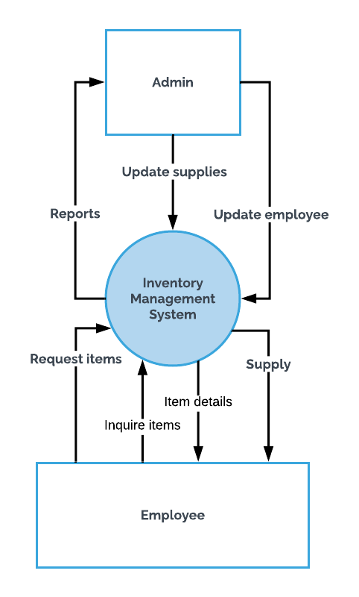

* 1. **Level 1 Diagram**

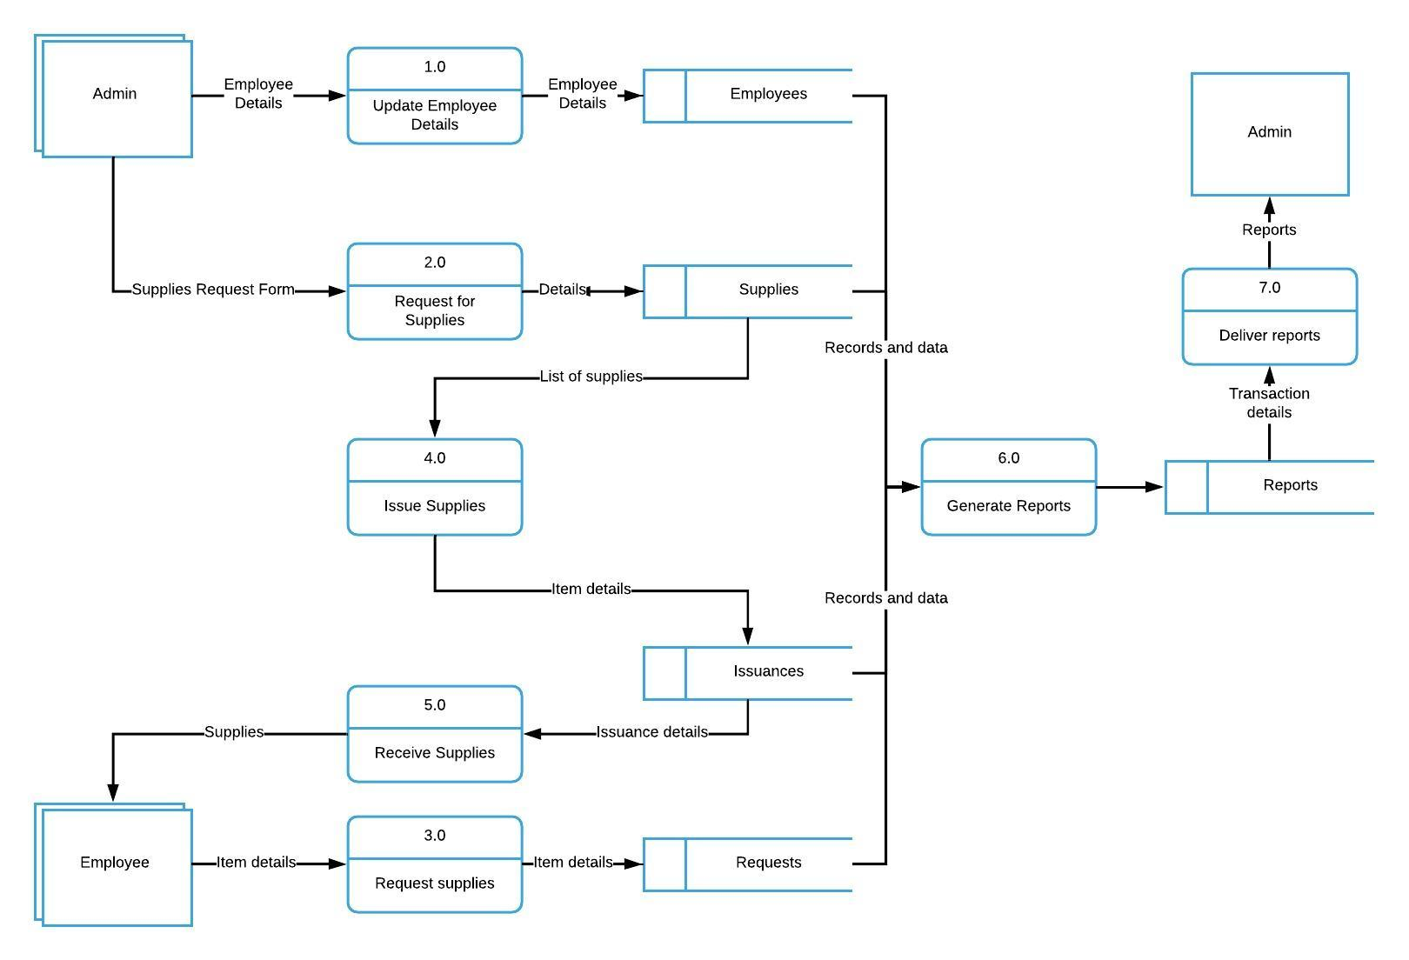

* 1. **Functional Decomposition Program**

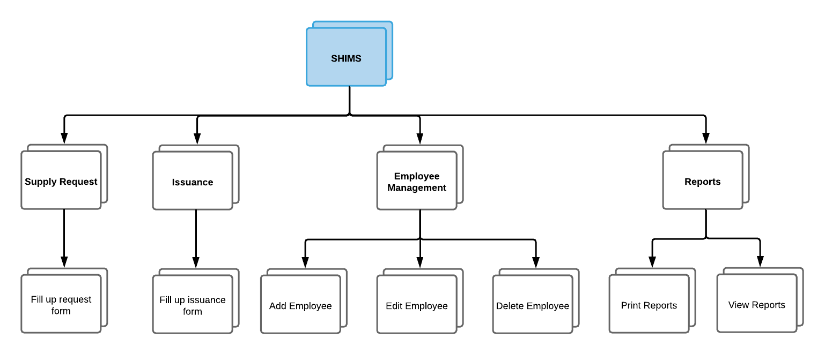

* 1. **Use Case Diagram**

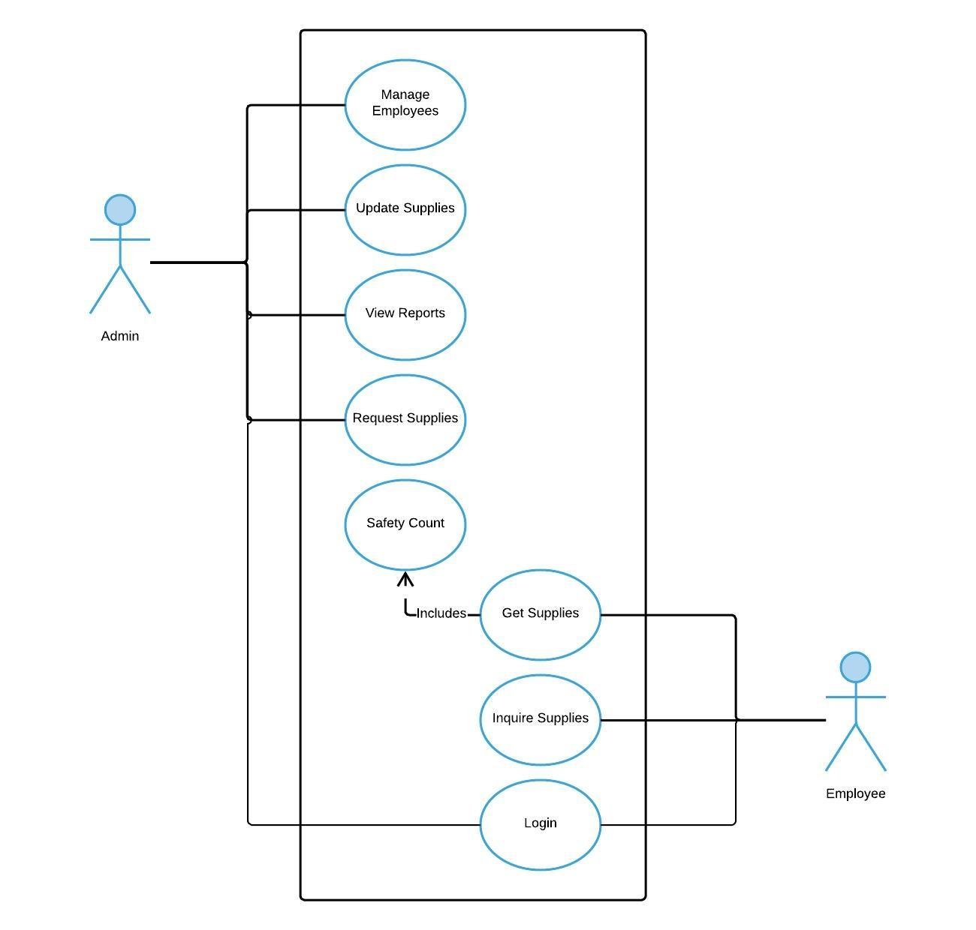

* 1. **Full Use Case Description**

|  |  |  |
| --- | --- | --- |
| Use Case Name | Update Employees | |
| Scenario | Admin adds, edits or deletes employee details | |
| Triggering Event | Updated employee details | |
| Brief Description | Employees wants to use the proposed system, the Admin then uses the system to add new employees and edit/delete existing employees | |
| Actors | Employee, Admin | |
| Related Use Case | Update Employee | |
| Stakeholders | System, Admin | |
| Preconditions | * Employee must provide his/her details * The system must be able to add new employees and edit/delete existing employees | |
| Postconditions | The system must display the updated details of the employee | |
| Flow of Activities | Actor | System |
| 1. Employee provides the following details to Admin: Employee Number, Name, Department, Photo 2. Admin adds/updates employee details in the system | 1. System reads the entered data if it exists with current database 2. If successful, the system displays the updated employee details |
| Exception Conditions | If unsuccessful or existing, the system will not process the modification and will display prompt to the Admin if employee is already existing or details entered are not valid | |

|  |  |  |
| --- | --- | --- |
| Use Case Name | Update Supplies | |
| Scenario | Admin adds, edits or deletes supplies | |
| Triggering Event | Updated inventory details | |
| Brief Description | Employee will add delivered supplies to the system and update existing supplies. | |
| Actors | Admin | |
| Related Use Case | Update Supplies | |
| Stakeholders | Admin, System | |
| Preconditions | * Employee must provide supply details * The system should detect similar items to avoid redundancy | |
| Postconditions | The system must display updated details of supply | |
| Flow of Activities | Actor | System |
| 1. Supplies are delivered to the warehouse 2. Admin provides the supply details to the system | 1. The system saves the updated data 2. If successful, the system displays updated supplies |
| Exception Conditions | If unsuccessful or existing, the system will not process the modification and will display prompt to the Admin if item is already existing or details entered are not valid | |

|  |  |  |
| --- | --- | --- |
| Use Case Name | View Reports | |
| Scenario | Admin requests for reports | |
| Triggering Event | Request for reports | |
| Brief Description | The Admin requests the system to generate various reports. The admin must select which type of report so that the system will be able to generate. | |
| Actors | Admin | |
| Related Use Case | View Reports | |
| Stakeholders | Admin, System | |
| Preconditions | * The data should be available within the time range * The spreadsheet viewer should support the generated file | |
| Postconditions | * The system should successfully generate reports | |
| Flow of Activities | Actor | System |
| 1. The admin chooses from the list of reports 2. The admin exports the report into spreadsheet | 1. The system queries the data requested 2. The system generates spreadsheet file |
| Exception Conditions | The requested data is empty and cannot be generated into file | |

|  |  |  |
| --- | --- | --- |
| Use Case Name | Request Supplies | |
| Scenario | Admin requests for supplies | |
| Triggering Event | Updated requests | |
| Brief Description | The Admin requests for supplies to be ordered. | |
| Actors | Admin | |
| Related Use Case | Request Supplies | |
| Stakeholders | Admin, System | |
| Preconditions | * Employee must provide supply details * The system should detect similar items to avoid redundancy | |
| Postconditions | The system should successfully save request | |
| Flow of Activities | Actor | System |
| 1. The admin provides the supply details | 1. The system saves the requested supply |
| Exception Conditions | The requested supply is already stored in the database | |

|  |  |  |
| --- | --- | --- |
| Use Case Name | Safety Count | |
| Scenario | The system detects a supply in low count. | |
| Triggering Event | Supply hits safety count. | |
| Brief Description | The system will automatically add the items that is in low count to requests. | |
| Actors | System | |
| Related Use Case | Inquire Supplies | |
| Stakeholders | System | |
| Preconditions | The supply is in safety count. | |
| Postconditions | The supply is added in requests. | |
| Flow of Activities | Actor | System |
| 1. The system detects supplies that are in low count | 1. The system adds the supply in requests |
| Exception Conditions | The supply is not yet in safety count | |

|  |  |  |
| --- | --- | --- |
| Use Case Name | Get Supplies | |
| Scenario | Employee will inquire supplies. An issuance will be made. | |
| Triggering Event | Getting of supply | |
| Brief Description | The employee will choose from the list of items and selects which item will be inquired. The system will then deduct the number of items issued. | |
| Actors | Employee | |
| Related Use Case | Get Supplies | |
| Stakeholders | System, Employee | |
| Preconditions | The requested amount of supply must not be more than the total amount of supply. | |
| Postconditions | The system should deduct the amount taken to the total amount of supplies. | |
| Flow of Activities | Actor | System |
| 1. The employee chooses from the list of supplies 2. The employee enters the number of supplies | 1. The system deducts the number of items issued 2. The system displays the updated supplies |
| Exception Conditions | The supplies will not be issued unless there is enough supplies for the request | |

|  |  |  |
| --- | --- | --- |
| Use Case Name | Inquire Supplies | |
| Scenario | Employee will inquire the list of supplies. | |
| Triggering Event | Viewing of supply | |
| Brief Description | The employee will view the list of supplies. | |
| Actors | Employee | |
| Related Use Case | Inquire Supplies | |
| Stakeholders | System, Employee | |
| Preconditions | The supply is in safety count. | |
| Postconditions | The supplies is not empty. | |
| Flow of Activities | Actor | System |
| 1. The employee views the list of supplies | 1. The system displays the list of supplies |
| Exception Conditions | The supply list is empty | |

|  |  |  |
| --- | --- | --- |
| Use Case Name | Login | |
| Scenario | User will enter the application | |
| Triggering Event | User login | |
| Brief Description | The user will open the application and specify whether he is admin or employee. | |
| Actors | Employee | |
| Related Use Case | Login | |
| Stakeholders | System, Employee | |
| Preconditions | User exists in database | |
| Postconditions | The user is redirected to role page | |
| Flow of Activities | Actor | System |
| 1. The employee selects whether enter as admin or regular employee | 1. The system will redirect the user based on role |
| Exception Conditions | The user does not exist in database | |

* 1. **Entity Relationship Diagram**

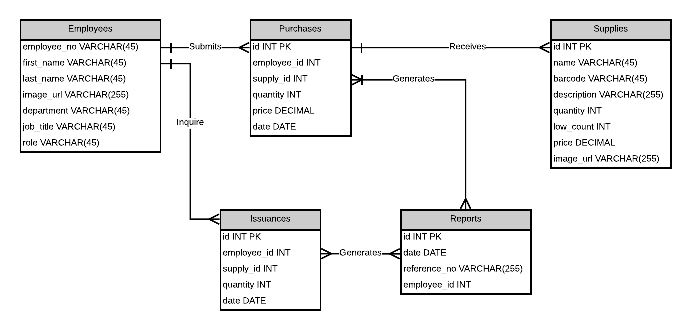

* + 1. **Data Dictionary**

|  |  |  |  |  |
| --- | --- | --- | --- | --- |
| TABLE: **Employee** | | | | |
| Field Name | Data Type | Field Length | Constraint | Description |
| employee_number | VARCHAR | 45 | PRIMARY KEY | Employee Number |
| first_name | VARCHAR | 45 | NOT NULL | Employee First Name |
| last_name | VARCHAR | 45 | NOT NULL | Employee Last Name |
| image_url | VARCHAR | 255 |  | Employee Photo |
| department | VARCHAR | 45 | NOT NULL | Employee Department |
| job_title | VARCHAR | 45 | NOT NULL | Employee Job Title |
| admin | BOOL |  | NOT NULL | Employee Role |

|  |  |  |  |  |
| --- | --- | --- | --- | --- |
| TABLE: **Supply** | | | | |
| Field Name | Data Type | Field Length | Constraint | Description |
| id | INT |  | PRIMARY KEY | Data ID |
| name | VARCHAR | 45 | NOT NULL | Supply Name |
| barcode | VARCHAR | 45 |  | Supply Barcode |
| description | VARCHAR | 255 |  | Supply Description |
| image_url | VARCHAR | 255 |  | Supply Photo |
| quantity | INT |  | NOT NULL | Supply Quantity |
| low_count | INT |  |  | Supply Low Count |
| price | DECIMAL |  |  | Supply Price |

|  |  |  |  |  |
| --- | --- | --- | --- | --- |
| TABLE: **Purchase** | | | | |
| Field Name | Data Type | Field Length | Constraint | Description |
| id | INT |  | PRIMARY KEY | Data ID |
| supply_id | INT |  | NOT NULL | Supply ID |
| quantity | INT |  | NOT NULL | Order Quantity |
| date | LONG |  | NOT NULL | Order Date |
| employee_id | INT |  | NOT NULL | Employee ID |

|  |  |  |  |  |
| --- | --- | --- | --- | --- |
| TABLE: **Issuance** | | | | |
| Field Name | Data Type | Field Length | Constraint | Description |
| id | INT |  | PRIMARY KEY | Data ID |
| employee_id | INT |  | NOT NULL | Employee ID |
| supply_id | INT |  | NOT NULL | Supply ID |
| quantity | INT |  | NOT NULL | Supply Quantity |
| date | LONG |  | NOT NULL | Issuance Date |

|  |  |  |  |  |
| --- | --- | --- | --- | --- |
| TABLE: **Report** | | | | |
| Field Name | Data Type | Field Length | Constraint | Description |
| id | INT |  | PRIMARY KEY | Data ID |
| reference_no | VARCHAR | 45 | NOT NULL | Report Reference Number |
| employee_id | INT |  | NOT NULL | Employee ID |
| date | LONG |  | NOT NULL | Report Date |

* 1. **Activity Diagram**
     1. **Activity Diagram - Item Request**

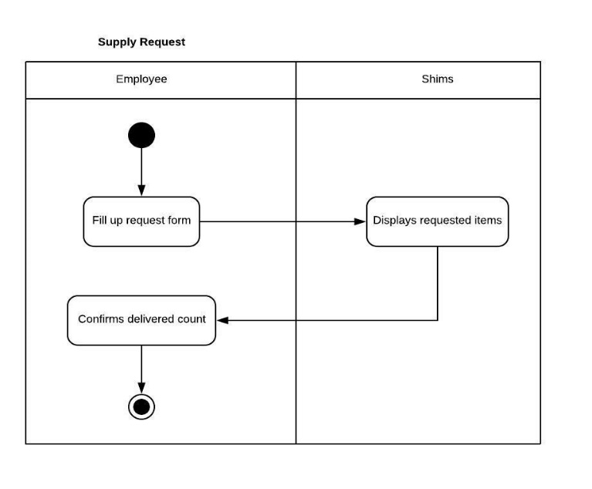

* + 1. **Activity Diagram - Add Employee**

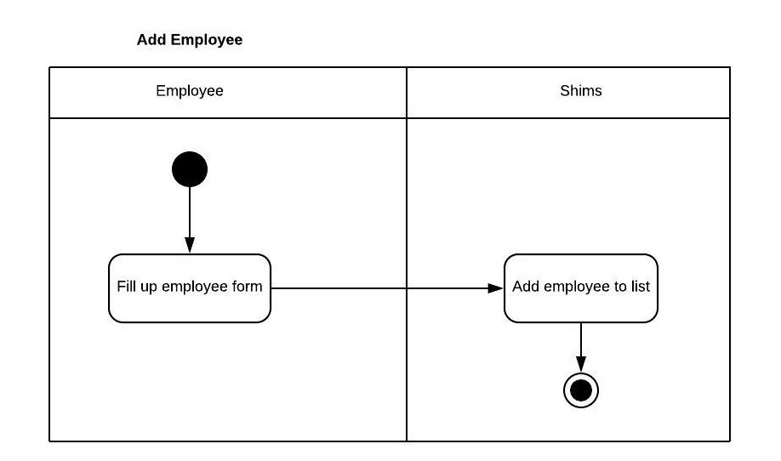

* + 1. **Activity Diagram - Issuance**

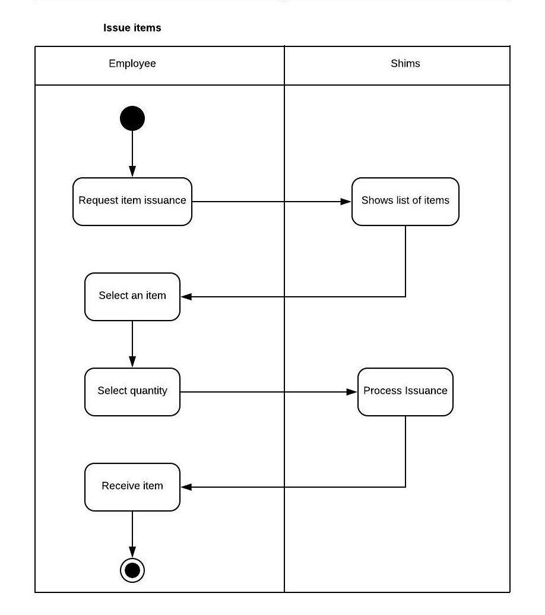

* + 1. **Activity Diagram - Generate Reports**

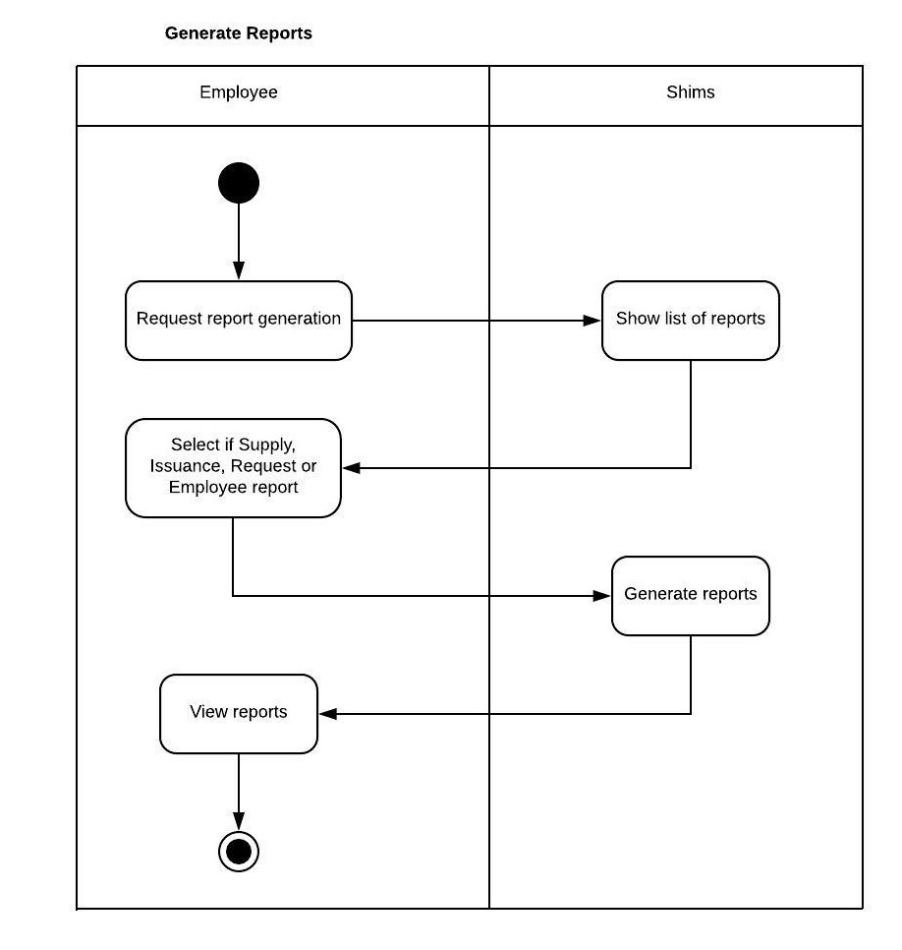

* 1. **Class Diagram**

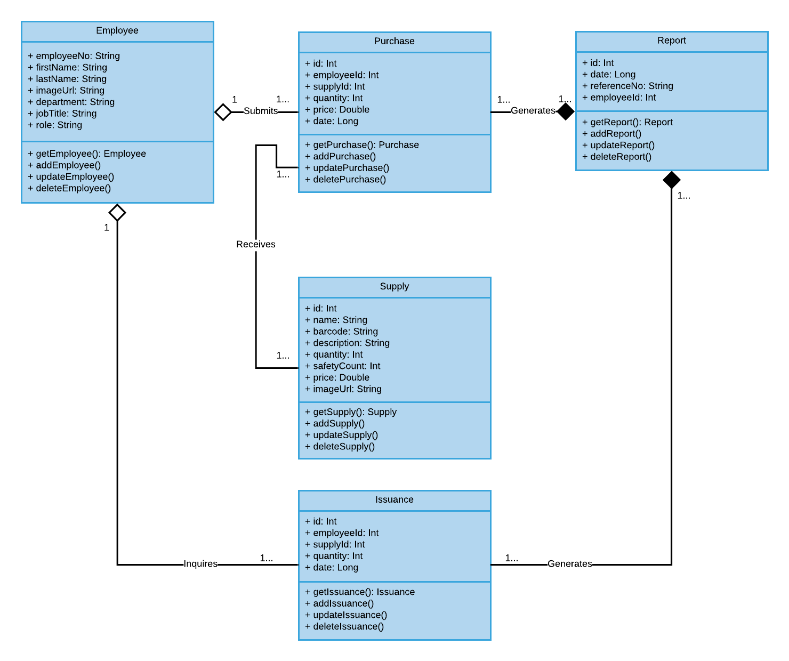

* 1. **Object Diagram**

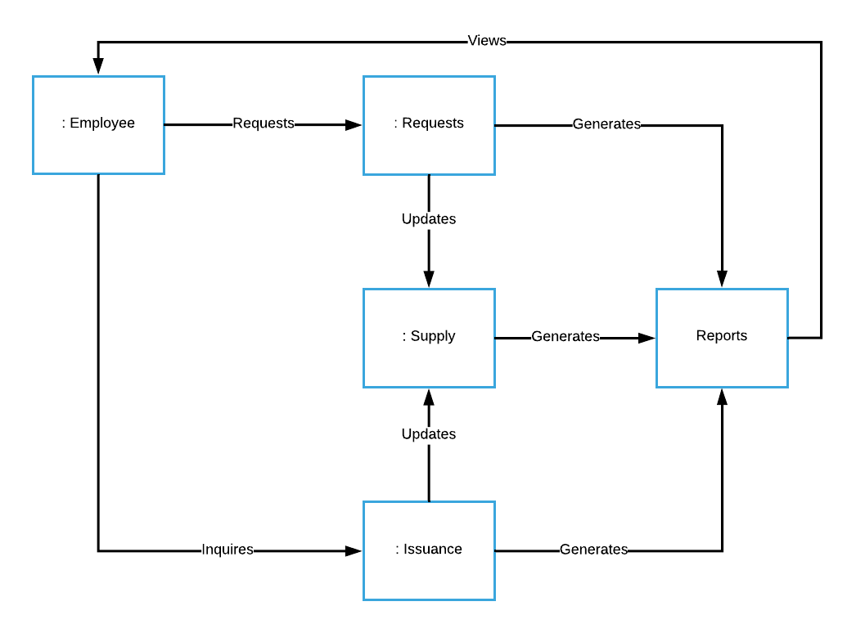

* 1. **Sequence Diagram**
     1. **Sequence Diagram - Request Supplies**

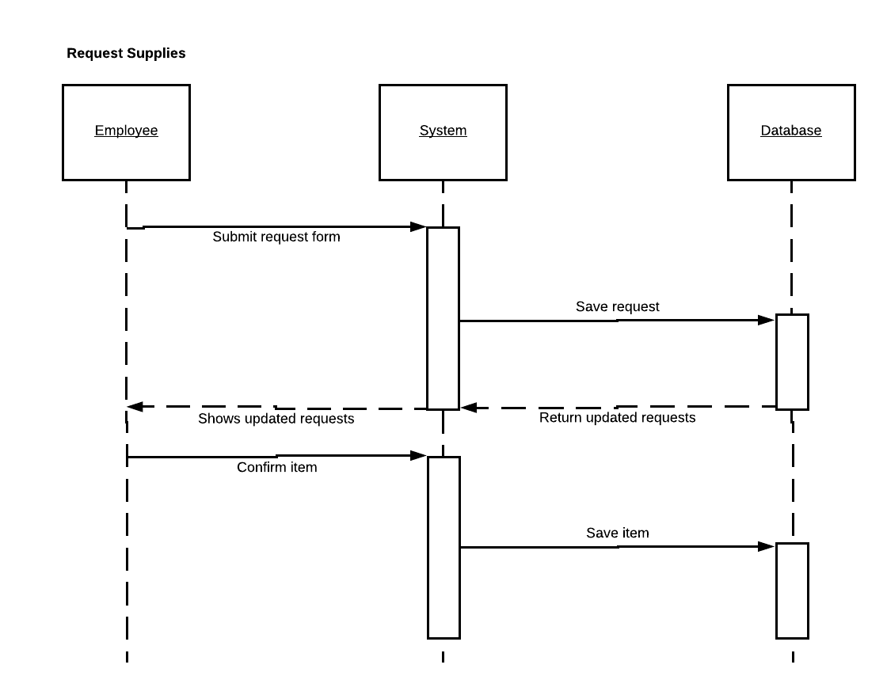

* + 1. **Sequence Diagram - Adding of Employee**

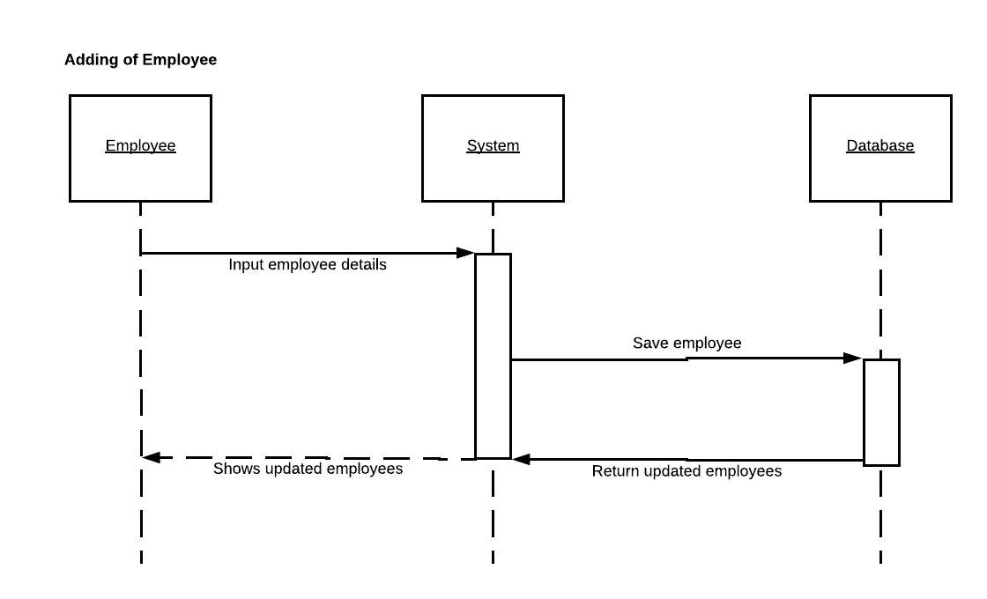

* + 1. **Sequence Diagram - Issuance of Supplies**

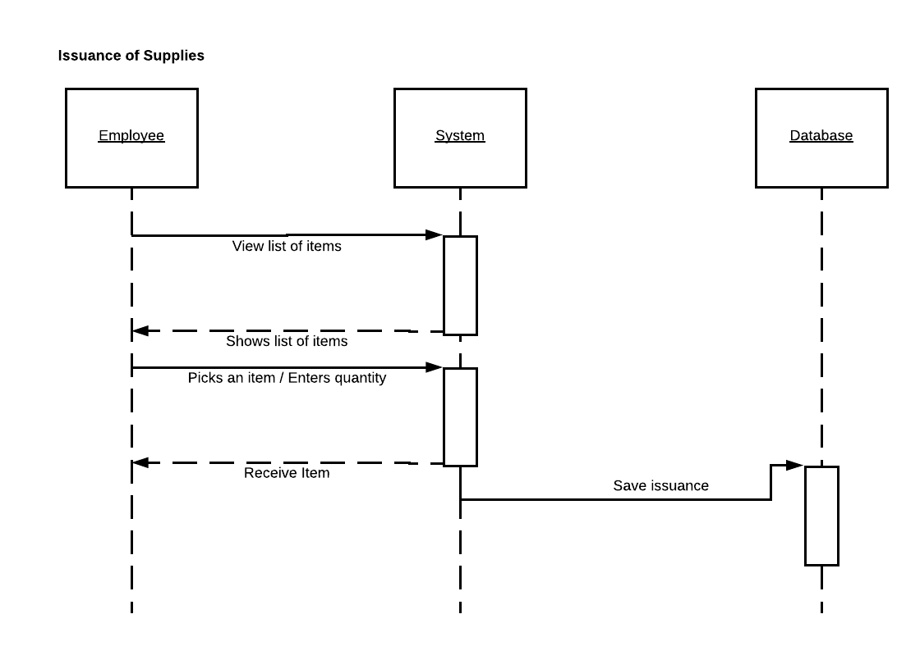

* + 1. **Sequence Diagram - Generate Reports**

